Curso de Ciencia de Dados
Seção 10

We replace missing data by median when they're numerical, or by the mode when they're categorical.
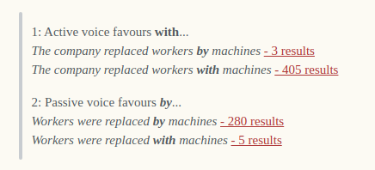

dataset = pd.read_csv("../dados/Churn.csv", sep=";") => reads csv
dataset.head() => shows header
dataset.shape => shows (number_of_lines, number_of_columns)
seaborn.boxplot(dataset['Score']).set_title('Score') => boxplot
seaborn.distplot(dataset['Score']).set_title('Score') => histograma
dataset["Idade"].describe() => shows statistical data
dataset.isnull().sum() => revela onde há ocorrencia de NA

